09 February 2016

DAVID C. TAN
Co-Convenor
Matuwid na Singil sa Kuryente Consumer Alliance inc. (MSK)
Unit 327, Eagle Court Condominium, Matalino Road, Brgy. Central, Diliman
Quezon City

Subject: Inquiries on PEMC’s Paper on the Impact of the Feed-In Tariff (FIT)

Dear Mr. Tan,

In relation to your letter dated 25 January 2016 requesting for details to understand the methodologies used in PEMC’s paper on the RE impact on the WESM prices, we would like to express our gratitude for your interest and appreciation of our paper. Hence, please find below our responses to your inquiries which we hope will provide enlightenment and further understanding of the data and assumptions used in our study.

- “From the press reports, this was based on the contribution of RE to the supply in Luzon and Visayan Grid of 682.91mw, consisting of 130.81mw biomass, 110.9mw of solar, 426.90mw of wind, and 14.3mw of run of river mini-hydro.”

Yes, this was based on the contributor of RE to the supply in Luzon and Visayas. However, we wish to note that the MW contributions noted above and used in the paper are only injections coming from renewable energy capacities that are under the Feed-In Tariff (FIT) system. This is in view of the objective of our paper, which is to estimate the impact of the integration of renewable energy resources through the FIT system.

- “We understand that the reduction in the WESM price as a result of these additional RE power is calculated in your study to be P1.00 per kwh. We request for information on how the P1.00 per kwh reduction was arrived at. From the reports, it was implied that your study ran the model of WESM prices without the 682.91 mw RE and with RE. The difference we assume was P1.00 per kwh.”

We wish to clarify that the P1.00 per kWh reduction was arrived at by taking the average difference of the load-weighted average price (LWAP) in the WESM for the study period from November 2014 to October 2015 that was calculated when we simulated the WESM prices on an hourly basis with and without the FIT-qualified resources. This means that the WESM prices on average, would have been higher by P1.00 per kWh if the FIT-qualified resources did not contribute to the grid during the study period. For further details on the methodology used in the paper, kindly refer to our response in item 3 below.

- “We request for information on the methodology of the comparison of the two that led to the conclusion that the difference was P1.00 per kwh.”

To provide further clarification on the methodology we used to determine the peso per kilowatt-hour impact with and without the FIT-qualified resources, we wish to inform you that we simulated the WESM prices on an hourly basis using actual price and quantity supply offers from generators, supply nominations from the RE generators and load demand from costumers (e.g., DUs). By using the aforementioned market inputs, the WESM price for each hour of the study period with FIT-qualified resources was simulated by determining the merit order table for each trading hours (Please see figure 1 below which illustrates the determination of prices for a given supply and demand condition ). To simulate the WESM prices without the FIT-qualified resources, the supply nominations from FIT-qualified resources were removed in the determination of the WESM prices. This process was also performed on an hourly basis.

After determining the hourly prices from the scenarios with and without supply nominations from FIT-resources the P 1.00 per kWh difference was then calculated by determining the average WESM price for each scenario for the study period November 2014 to October 2015.
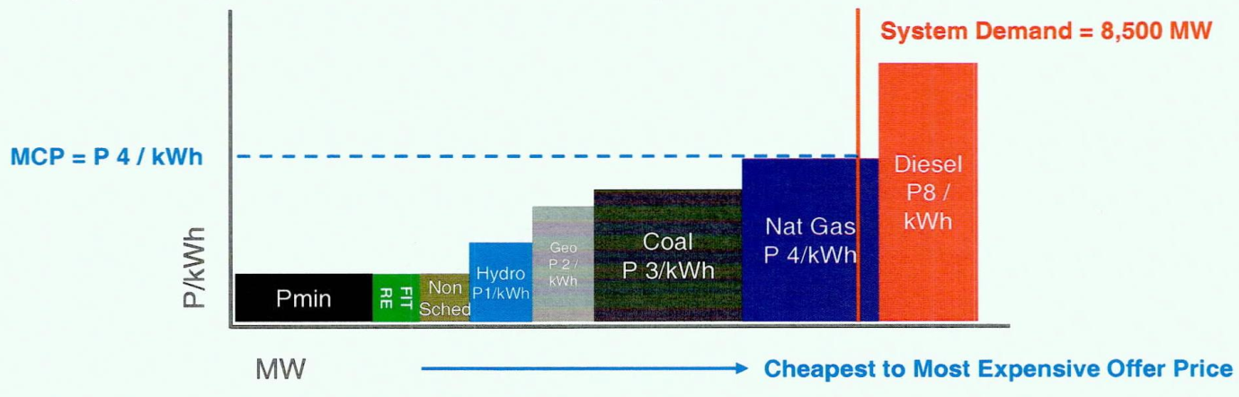

Figure 1. Merit Order Table inclusive of supply from FIT-qualified Resources

To further explain the determination of prices considering the merit order table shown in figure 1 above, please note that in the above example, a 8,500 MW demand resulted to a market clearing price (“MCP”) of P 4 / kWh. In this example, the price corresponds to the spot price with the FIT-qualified resources present in the supply stack. To simulate the price without the FIT-qualified resources present in the supply stack. To simulate the price without the FIT-qualified resources, the FIT RE block is removed from the merit order table. This is illustrated in the figure 2 below.
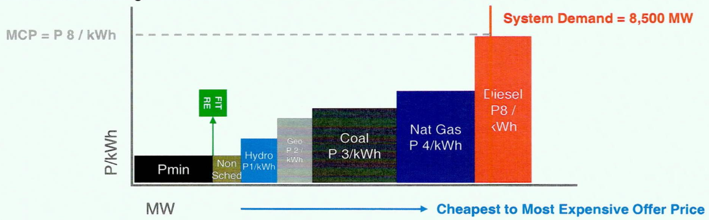

Figure 2. Merit Order Table without supply from FIT-qualified Resources

As can be seen in figure 2 above, keeping the demand constant, the simulation indicates that the diesel plant was required to serve the demand of the system without the FIT-qualified resources, which resulted to a MCP of P / kWh in this example. The conclusion for this example then is that the presence of the FIT-qualified resources resulted to a P 4 / kWh decrease in the spot price for the specific interval.

The process illustrated above was then performed for all of the trading intervals for the study period November 2014 to October 2015. It should be noted that the removal of the FIT-qualified resources in the merit order table does not always result to an increase in spot prices or may only result to a minimal decrease in spot prices. The impact on spot prices is based on the quantity that cleared in the market and the prices of the preceding offers in the stack. For example, if the last offer quantity that cleared was 100 MW then removing 75 MW of IT-qualified resources in the offer stack will not result to any changes in the spot price. Moreover, if the offer price of the preceding offer quantity is only a slight change from the current spot price then the removal of FIT-qualified resources in the stack would only result to a minimal decrease in price. Using figure 2 as an example, if the spot price is the offer price of the natural gas plant (P 4 / kWh) then the spot price could have decrease only to the offer price of the coal plant (P 3 / kWh), which is smaller than the decrease in the previous example where the spot price decreased from the offer price of the diesel plant (P 8 / kWh) to the offer price of the natural gas plant (P 4 / kWh). The reported P 1.00 per kWh then includes the intervals with significant decrease, with minimal decrease, and no decrease.

- “Since 537.8mw of the 682.91 mw RE or about 79% are of the intermittent type (solar and wind), how was the cost of ancillary and reserve services factored in the study. Further, let us note that the diesel plants in Luzon, Bauang and Navotas are already contracted with capacity fees by Meralco for peaking and reserve and charged to the customers. If they are displaced by Solar and Wind, Meralco consumers still pay. How was this factored in the net economic benefit of RE to the consumers?.”

In terms of additional ancillary service requirements to address the impact of the FIT-resources to the system security and reliability of the grid that may be brought about by the intermittency of supply from solar and wind plants, we wish to note that no additional cost for ancillary services were assumed in the paper (italic supplied). This assumption is brought about by the fact that the system operator (NGCP) did not file with the ERC for any additional reserve requirements to specifically address intermittency of RE; hence, the assumption is that the current ancillary service supply is sufficient considering the current penetration level of RE in the grid. On the other hand, we do not discount the possibility that the system operator may require additional reserves in the future.

In terms of additional reserve supply from the diesel plants contracted to Meralco, we wish to inform you that our paper did not consider any impact on the bilateral contracts of the customers as PEMC is not privy to the intricacies of the bilateral contracts of industry participants. The figures presented only include the impact of the additional payment to FIT-qualified resources and the impact of the reduction in spot prices due to the priority dispatch of FIT-qualified resources.

- “Solar tends to produce power only for 5 to 6 hours from 11am to 5pm which on average are non-peak hours. Did your WESM data show that the expensive bunker

Plants are also normally dispatched during these same hours to make the displacement basis of the study viable? Our sense is these expensive diesel plants are more dispatched during the peak hours of 6 to 10pm night time when actually the Solar is not producing electricity. We are wondering about the validity of valuing the impact of RE to the consumers by using diesel power as the avoided cost.”

With regard to your query regarding the usual operation of solar and diesel plants, solar power plants generate the bulk of their energy from 8AM to 4PM according to WESM data. As a result, the dispatch of diesel plants during those hours were lessened. Based on your simulation, the production from diesel plants were reduced by an average of 22% during the same timeframe (i.e., 8AM to 4 PM) due to the integration of all FIT-qualified resources in the WESM. We would like to note that the decrease in the dispatch of diesel plants in the WESM not only reduces the cost of the quantity displaced but also decrease the cost of the whole spot market. This is because the WESM implements uniform pricing which settles all spot transactions based on the offer price of the last power plant necessary to meet the demand of the system. When diesel plants are not cleared in the market, they also do not set the price that is applied to all spot transactions. As a result, even if the displaced quantity of diesel plants may not be significant, the impact on costs may be much larger.

We would also like to note that the FIT-qualified resources also displaced other technologies besides diesel but a lesser degree. Based on the simulations, the integration of FIT-qualified resources from 8AM to 4PM also resulted to the reduction in the dispatch of coal plants (2%), hydro plants (3%), and natural gas plants (1%).

- “How about the energy injection pattern of Wind? Were they directly related to the timing of the infusion of diesel power in the market? How do we account for the cost of having those diesel plants ready to support the supply intermittence of Wind and Solar?”

On your inquiry regarding the energy injection pattern of wind power plants, wind power plants generate the bulk of their energy from 12PM to 9 PM according to WESM data. Unlike solar power plants however, wind power plants may still generate around 80% of its peak generation outside those hours. This further reduces the need to dispatch diesel plants in the market; consequently the diesel plants also do not set the price of the market. The reduction in the dispatch of each type of plant during the hours when solar is not available but the rest of FIT-qualified resources are available, including wind, (5PM to 7AM) is 2% for coal, 2% for hydro, 1% for natural gas, and 6% for diesel plants. As mentioned in our reply to item 4 above, we assumed that there were no additional costs for ancillary services associated with the integration of FIT-qualified resources. Again, this is based on the fact that the system operator did not file with the ERC for any additional reserve requirements to specifically address intermittency of RE.

- “Did the market price study compare the WESM price impact if those 682.91mw of increased WESM supply from RE which has a FIT cost of P8.00 kwh, is instead supplied by new coal or natural gas power plants at P4.50 per kwh or even by more diesel plants that can deliver power on call and whose current generating cost is P7.50 per kwh due to the lower cost of bunker. In other words, did the claimed reduction in WESM price because it is RE or it is just additional supply?”

The market price study did not compare if those 682.9 MW of increased WESM supply were from new coal, natural gas power plants or diesel plants. Although those conventional plants may be said to be cheaper than developing renewable energy, the accelerated development of renewable energy resources in the country through special programs such as the FIT system is a thrust of the government. The integration of FIT-qualified resources, however, also has cost benefits to the system, more specially on WESM prices, as has been experienced in other jurisdictions. The objective of PEMC’s paper is to estimate the benefit on WESM prices based on historical data.

- “Did you run a financial model on the price difference of WESM when the RE capacity goes up to 30% or 4,000mw of the installed capacity of the country as targeted by the DOE?”

We wish to inform you that we did not run a financial model on the price difference of WESM when the RE capacity goes up to 30%. The objective of PEMC’s paper was to estimate the impact of the integration of FIT-qualified resource to the WESM for the period November 2014 to October 2015. This was performed using actual historical data available in the market.

We hope the above responses have provided you a clearer understanding of the methodologies and conclusion of our paper. Pease note that studies such as these are generally aimed at informing various stakeholders on the possible impact of policies and regulations to the WESM. Should you have additional questions or require further clarifications, please do not hesitate to communicate it with us.

Thank you very much.

Very truly yours,

ROBINSON P. DESCANZO
Vice President, Corporate Planning and Communications

cc: Pres. Melinda L. Ocampo, PEMC
Senator Loren B. Legarda, Philippine Senate
Secretary Zenaida Y. Monsada, DOE
Chairman Jose Vicente B. Salazar, ERC
Atty. Jose Alejandro, PCCI-Power Committee Chair
Former DOE Secretary Carlos Jericho L. Petilla

